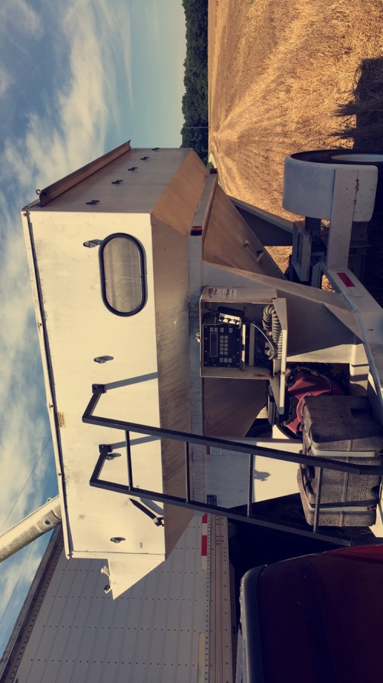

Monday in Essex Keith and I went to a green infrastructure review committee meeting in the county administration building in Tappahannock. They were going over different maps (water, forest, recreation, etc.) with the selected people that were there to get more information on what are the important parts that people in this area think should be focused on, so that it can be added to the state data of maps. That afternoon we went to Craig Branns farm in the Northern Neck area to cut a 3 acre section of wheat and weigh it so he could be entered into the state wheat yield contest. Keith was then going to take a sample to have the moisture checked so we could do all of the calculations.

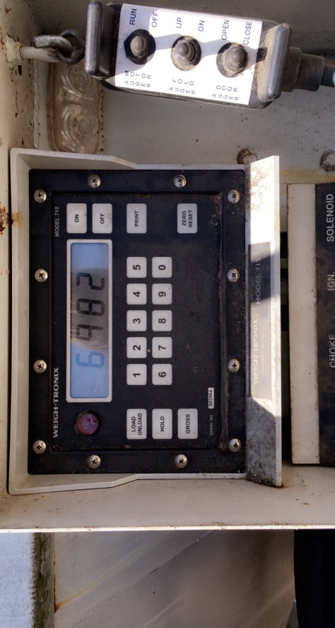

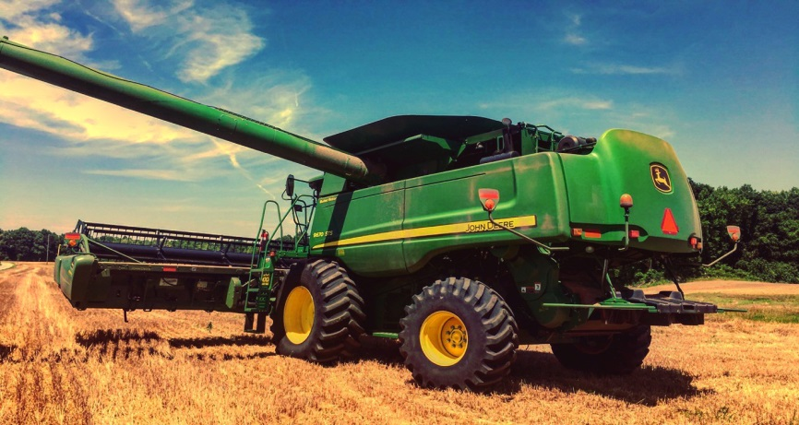

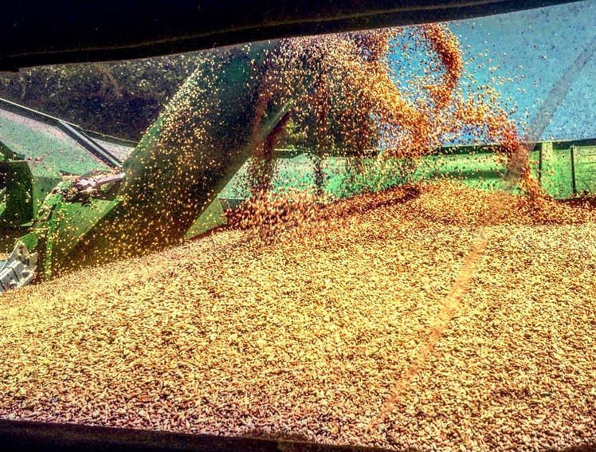

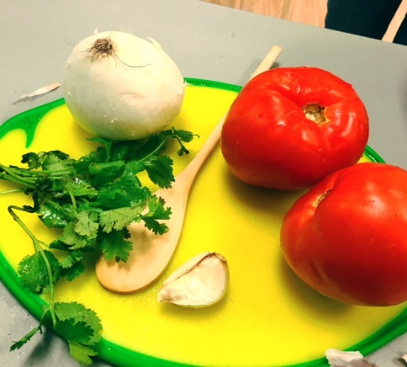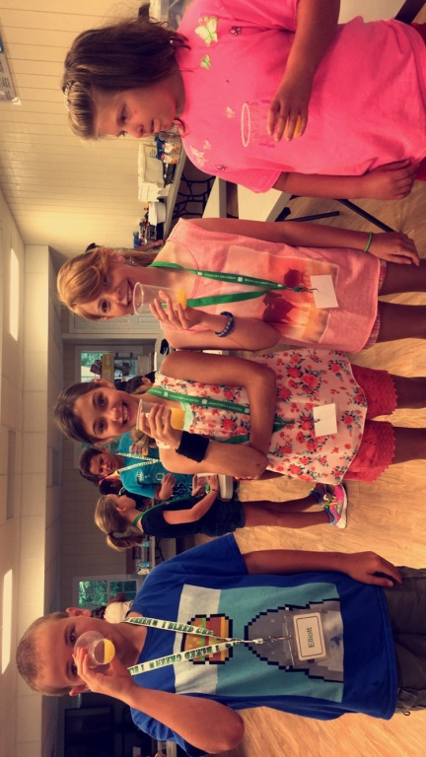

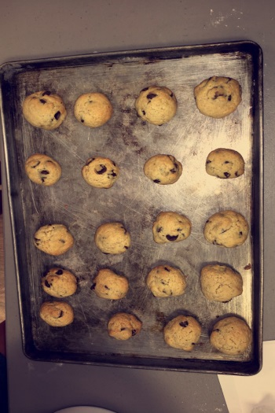 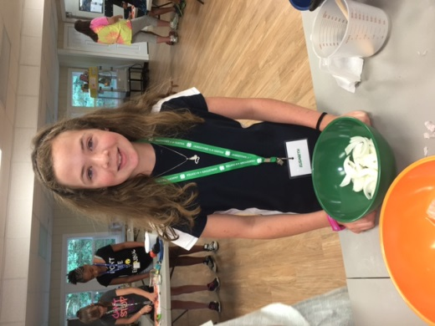 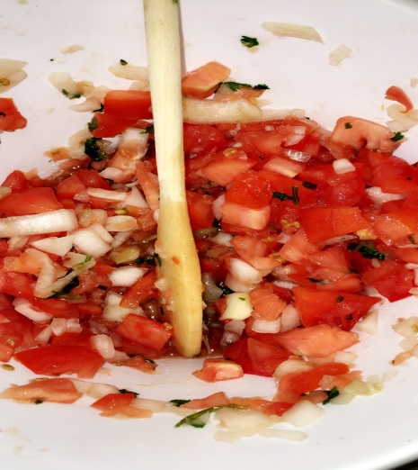

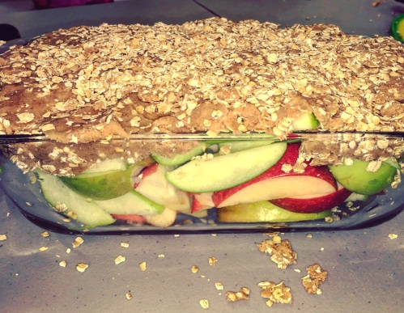 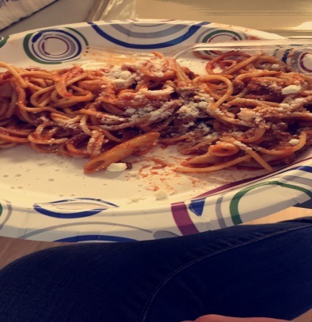 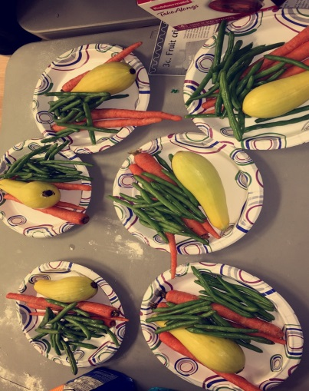

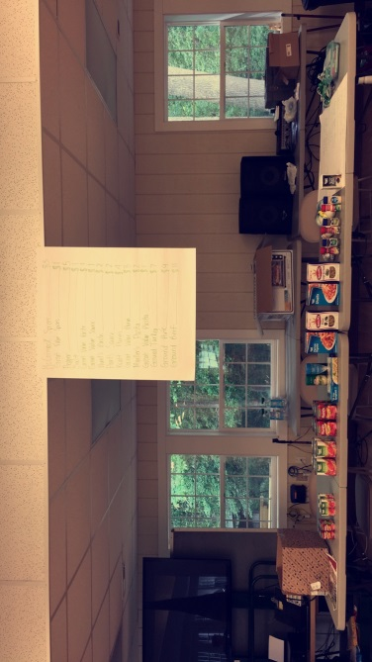 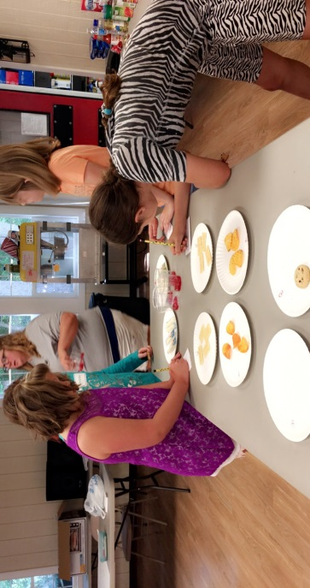

This week Karlee and Mary Lee held a 4-H Food Challenge camp for ages 9-13. On the first day of camp the youth made homemade fruit flavored soda, salsa and corn chips. Brittiany and I showed them how to properly cut the vegetables they were using to make their salsa. That afternoon the kids made homemade chocolate chip cookies, and did an activity with someone who came and spoke with them about nutrition and what portions of each part of the diet they should be eating. On the second day the kids had a guest speaker come talk with them about fire safety in the kitchen, and how they can prevent these fires from happening. We set up stations where the youth were able to taste different items (cookies, chips, cheese, etc.) we were trying to see if they could taste the difference between store brand and an actual brand. They used what they learned from this activity to help them with their lunch. They made their own spaghetti lunch. Within their groups they had fake money to come spend at the store we had put together with all spaghetti supplies. They had to decide within their groups which items were more important to be store brand or a name brand before they came up to purchase. In the afternoon they made a vegetable casserole and apple crisps. Overall I feel the youth had a good time, and learned something new about cooking, and being creative with cooking. This was a good experience for me to see how youth programing works, and what planning needs to go into it for it to be successful.