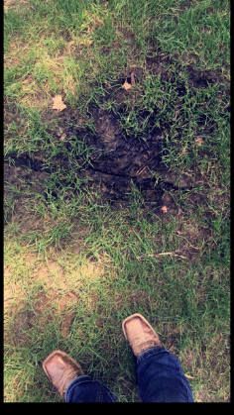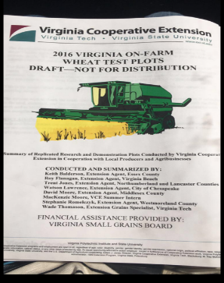

At the beginning of the week David and I worked on get the details worked out for the hay program we are having this Tuesday. We also made a visit to a woman’s house to look at her backyard. We determined that it is a form of mold growing because the yard is not ever getting enough sunlight for the ground to dry out. Tuesday David and I went to the Small grains meeting to give our presentation of the wheat publication we had put together of the results of this year’s testing plots, where we were also asking for funding for next year so extension can do more research. On Wednesday with Keith in Essex I worked on getting some more information typed up information into charts and put into the computer for us to use for in the future. Thursday I spent the day with Racheal and Karley at clover bud camp in Middlesex. I think all of the kids had been enjoying their time at camp over the week. I enjoyed getting to know them and working with them on their last day of camp which included a waterslide! An article about me was posted in the Southside Sentential on Thursday which talked about my internship and my background within the industry. Over the weekend I visited two producers to get hay samples for the hay program this week. This picture of some katahdin hair sheep from on if the farms. They are currently being bred to have fall and early winter lambs. This weekend I also worked on getting things ready so I can help Mathews with Animal Science this week for their day camp. I have been working on getting pig ears cut out for ear notching and getting eggs ready for grading.

