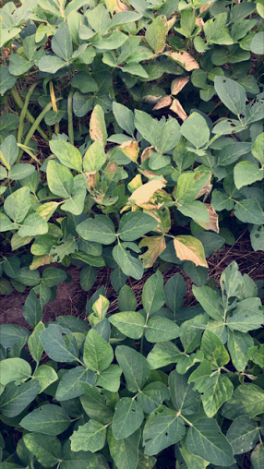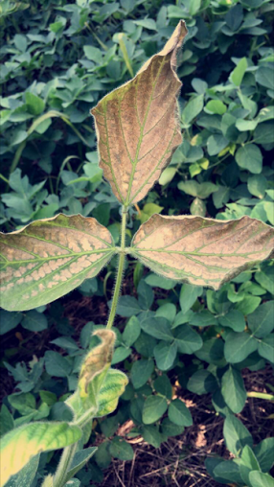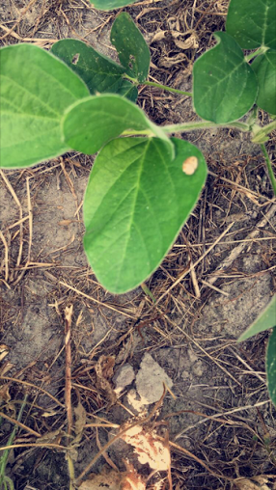
on Monday I finished up the PowerPoint for the hay program and got together packets of information that David had printed off to give out. Later in the day david and I went to look at some soybean fields we saw some cupped leaves, and very spread out damaged spots. David was not 100% sure of what might be wring so we took some leave samples to have sent off. We did find some Kutzu bugs on some leaves.

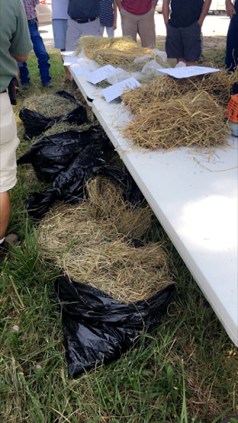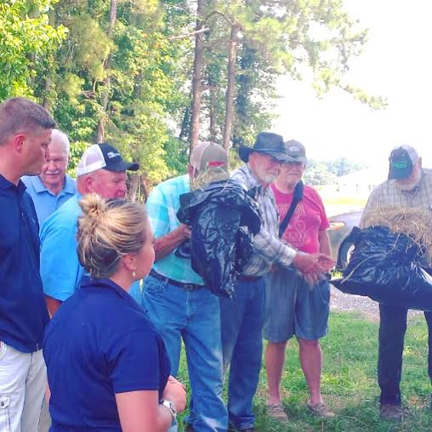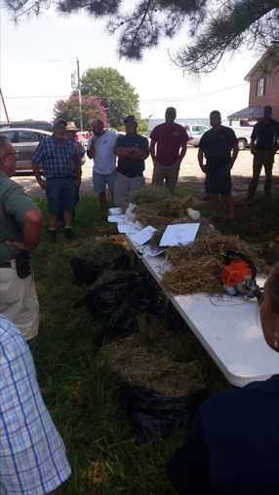
Tuesday was the Hay Program held an Nicks in Saluda. Dr. Chris Teutsch came and spoke with everyone about hay production in all concepts. Chris’ graduate student came and spoke about the hay exporting project that he has been working on. I brought a few samples of quality hay from the valley and showed everyone and spoke to them about what type each one was and what the producer was using the hay for. David gave a PowerPoint on common hay field weeds, and also talked about how they can be controlled.
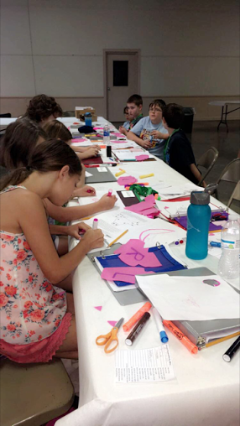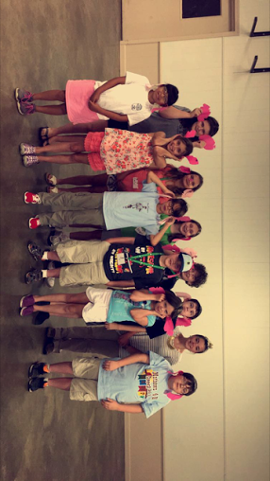
Wednesday keith and I helped out for Mathews County Animal Science day camp. I brought along two lessons. The first lesson was about piglet processing and the main activity we focused on with the kids is ear notching. I chose this activity from piglet processing because it can be taught and somewhat practiced without actually having to have the live animal there. The second activity I used was exterior and breakout egg quality where the kids were able to learn how to grade an egg by looking at the shell and then they were able to brake open eggs and see how not every egg inside is the same and they learned how to grade the parts of the egg. Keith then spoke about the Essex livestock club that he has and tried to gain interest for the Mathews kids.

On Thursday I spent the day with Keith putting together spreadsheets for the 2016 plot harvest results. Then on Thursday afternoon we met with the manager in Mechanicsville with colonial Farm Credit to talk about the Essex County Agriculture and Forestry Directory. I am going to be working on this over the next few weeks so they can have an updated version to put on the county website.

