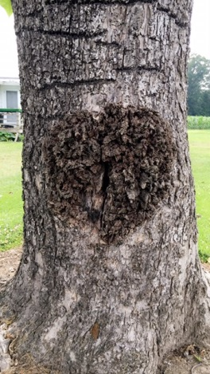

On Wednesday I separated some wheat heads from the straw for Keith so he could send them off to a specialist to be looked at. I also typed up some charts for nematode surveys as well as for some tissue sample results of nutrients. Thursday Keith, Stephanie, and I went to West Moreland County to help cut a wheat test plot. Here I helped to do the moisture test as well as the test weight for each variety.

At the beginning of the week with David I have been working on a PowerPoint for him to give at our hay program at the end of the month. This PowerPoint is on different types of common weeds that come up in hay fields that can affect the animals that are eating it in the pasture and after it is bailed. It also goes over how to control these weeds. We had lunch with farm credit this week. We took some wheat samples to west point to Old Dominion to have the moisture checked. We also had a call to come look at a tree that looked like it was rotting; David thinks it is where a limb was cut and has not sealed. Lastly we put in the light trap at a farm to start attracting corn ear worms once the larva turn to adults to attract the to the light to keep them from moving on to soybeans.

